

# Vtech Careline 20750E Corded Deskset

## Type of device: Landline - Standard

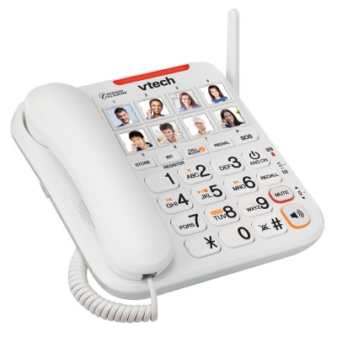

Button Type : Physical Keypad

Average Price : $55 as of 29 06 2022

## Accessibility Features:

### Cognitive

Photo Telephone List

### Vision

* Key Marker – Raised '5'
* Key Numbers - Standard Layout

Key Press - Vibration or Click

### Physical

* Flat Back for Table Top Operation

Speaker-phone option

## How and where to get it from?

You can buy this phone from [Officeworks](https://www.officeworks.com.au/shop/officeworks/search?istCompanyId=0403b0ba-0671-498f-aeb7-e2ff71b61924&istFeedId=00ff5695-1f12-4ff3-82f4-49dd39a43a69&istItemId=pqitxrrpa&istBid=t&cm_mmc=Google:SEM:Always_on:RP|Technology|Audio|Speakers%20&%20Smart%20Speakers||||SH||=&s_kwcid=AL!12073!3!544100860980!!!g!912150888938!s_kwcid=AL!12073!3!544100860980!!!g!912150888938!&gclid=CjwKCAjwzeqVBhAoEiwAOrEmzVhOzRoyy4mLQddU0pshtKmoPccMpIsZLEON7qR85hacp7bOpz6BKRoCSxkQAvD_BwE&gclsrc=aw.ds&q=VTech%20Careline%20Phone%2020750E&view=grid&page=1&sortBy=bestmatch), and other retailers.

## More information is available on:

[Vtech Careline 2050E Corded Desktop User Guide PDF Website](https://auphones.vtech.com/assets/data/products/%7B261602B7-58AE-456D-9D3B-D5418E05FB78%7D/manuals/CLS20750Euserguide.pdf)

[Vtech Careline 2050E Corded Desktop Website](https://auphones.vtech.com/home-phones/corded+cordless-phones/498)